**Adding Multi Factor Authenticator App to new phone**

1. On a computer, go to Multi Factor Authenticator Link [https://aka.ms/mfasetup](https://nam04.safelinks.protection.outlook.com/?url=https%3A%2F%2Faka.ms%2Fmfasetup&data=04%7C01%7Cjsanders%40forsyth.k12.ga.us%7Ce059e49d8ac54aa63dff08d8b63b8115%7Cbc41c1b937824402a9e2bf8c71255790%7C0%7C0%7C637459713971671038%7CUnknown%7CTWFpbGZsb3d8eyJWIjoiMC4wLjAwMDAiLCJQIjoiV2luMzIiLCJBTiI6Ik1haWwiLCJXVCI6Mn0%3D%7C1000&sdata=DTUmoc3%2FZM9eBixDv5ExKr4kcW7MJ%2F9sVhmKwq8BgNA%3D&reserved=0)

1. You will be prompted to approve the sign in request. Since you don’t have the app setup on your new phone select “Sign in another way” or “I can't use my Microsoft Authenticator app right now.” (This option seems to vary.)

1. ***Select Text option*** *(if the new phone is the same number as the previous phone number)*

*\*If you never added your cell phone number to Authenticator, you will not see the text option and will need to add that number before being able to move forward with these directions.* [*Watch this video for how to add that phone number*](https://youtu.be/NcZbS1rj7AM)*. Wait 30 minutes and then start these directions again.*

1. Your phone will receive a Text with a Verification Code to enter.
2. Enter the Code and Select Verify
3. On your computer, next you should be prompted with your profile.

* In the list of authentication methods, find the Microsoft Authenticator choice and ***Delete*** the old phone (Might show Iphone or the name of the device).
* Now select **Add method** and select Authenticator app from the dropdown of choices.

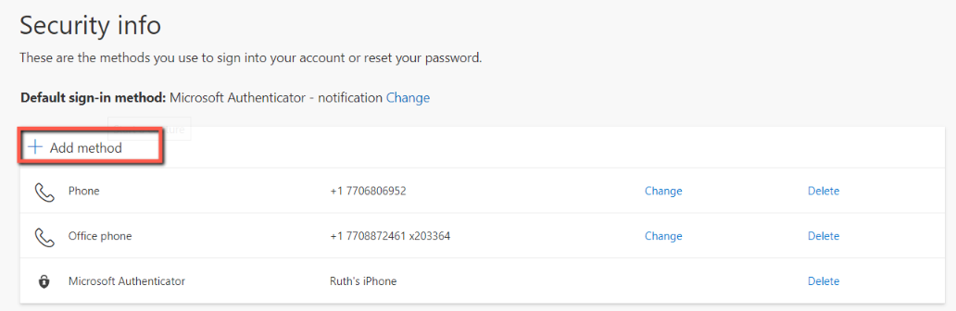

1. Follow the directions in the windows that open. Click *Next* until you get to the QR code.
2. On new phone, open Authenticator App.
   1. If your previous account is showing on the Authenticator App, click the arrow pointing right at the end of your account.
   2. On the next screen, click the settings wheel in the upper right corner.
   3. On the following screen, click *Remove account*.
   4. You should then be taken to an option to Add account. Select Add account.
   5. Select *School or Work Account*.
3. Using the Authenticator App on your phone, scan the QR Code from the website
4. After you scan the QR Code select Next on the computer (Prompts to Approve the sign in will display on your phone)
5. ***Select “Approve”***
6. Once the account has been added, you will notice your new phone displayed in your profile.

** After adding the Microsoft Authenticator to your new phone, you will need to change your Default sign-in method .

1. On the computer (the aka site that you have been using), find where it says *Default sign-in method*.
2. Click the *Change* link at the end of that line.
3. From the options that come up, select *Microsoft Authenticator*.